**Assignment SSIS on Sakila**

1) Rental

Source: neu_workshop.dbo.rental

Destination: sakila.dbo.rental

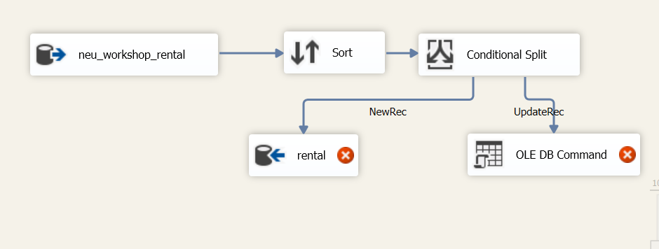

2) Payment

Source: neu_workshop.dbo.payment

Destination: sakila.dbo.payment

